**HTML Attributes**

**Attributes:**

HTML attributes provide additional information about the HTML elements.

All HTML elements can have attributes.

Attributes provide additional information about elements.

There may be more than 1 attributes in HTML Elements.

Attributes are always specified in the start tag.

Attributes usually come in name/value pairs like:

**Syntax:**

name="value"

**Representation:**

<tagname attributeName=“attributeValue”>Content goes here...</tagname>

**The href Attribute:**

The <a> tag defines a hyperlink. The href attribute specifies the URL of the page the link goes to:

**Example:**



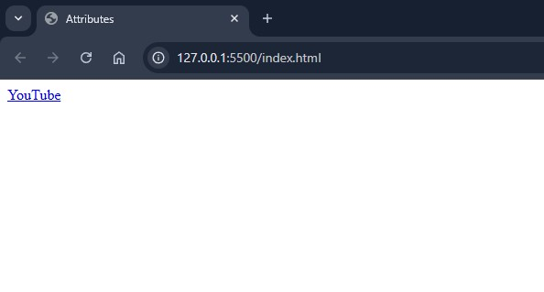

**The src Attribute:**

The <img> tag is used to embed an image in an HTML page. The src attribute specifies the path to the image to be displayed:

**Example:**



